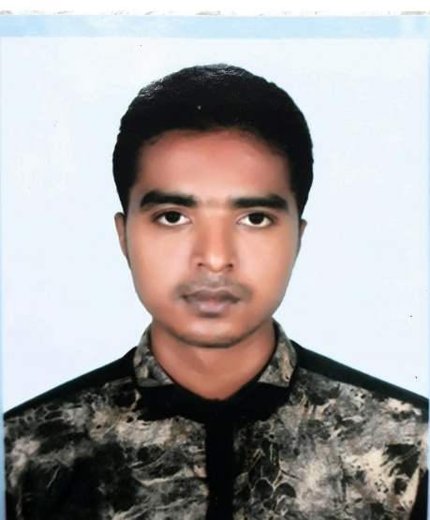***RESUME***

***OF***

***Md Rahnatul Islam***

***Career Objective:***

To serve in a responsible position at a well-structured organization successfully apply analytical ability and interpersonal skills to enhance organizational efficiencies.

***Scholastic Bref:***

* **Secondary School Certificate (S.S.C)**

Result : 4.63

Group : Science

Board : Dhaka

Passing Year : 2010

* **Higher Secondary Certificate (H.S.C)**

Result : 4.10

Group : Science

Board : Dhaka

Passing Year : 2014

* Running Study : C.S.E Engineering of Southeast University of Science & Technology – 3rd Year.

***Computer Knowledge:***

* Office Tools: MS Word, MS Excel, MS Power Point.
* Internet/web: Internet Browsing, e-mail checking, surfing the internet.

***Language Proficiency:***

Have an excellent command and knowledge on Bengali and English both oral and written.

***Experience :***

N/A

***Professional Information:***

Father's Name : Md Anwar Hossain

Mother's Name : Mrs Razia Sultana

Nationality : Bangladeshi (by birth)

National ID Card No : N/A

Date of Birth : 23 June 1995

Religion : Islam

Marital Status : Unmarried

Gender : Male

Blood Group : B+ (Positive)

Height : 5 Feet & 7 Inch

Contact Number : 01686-454251 , 01789-894026

E-mail Address : rahnatulislam39@gmail.com

***Present Address*** :House # 151/3, Shah Ali Bagh,

Mirpur-1, Dhaka- 1216.

***Permanent Address*** : Area- 311/3, Palongpara, P.O-Kaliyakoir,

P.S- Kaliyakoir, Dist- Gazipur.

By my signature below, I certify that to the best of by knowledge the information provided in my resume is accurate and complete.

***Signature***

***Md Rahnatul Islam***

Date : ...........................